1. command-line options

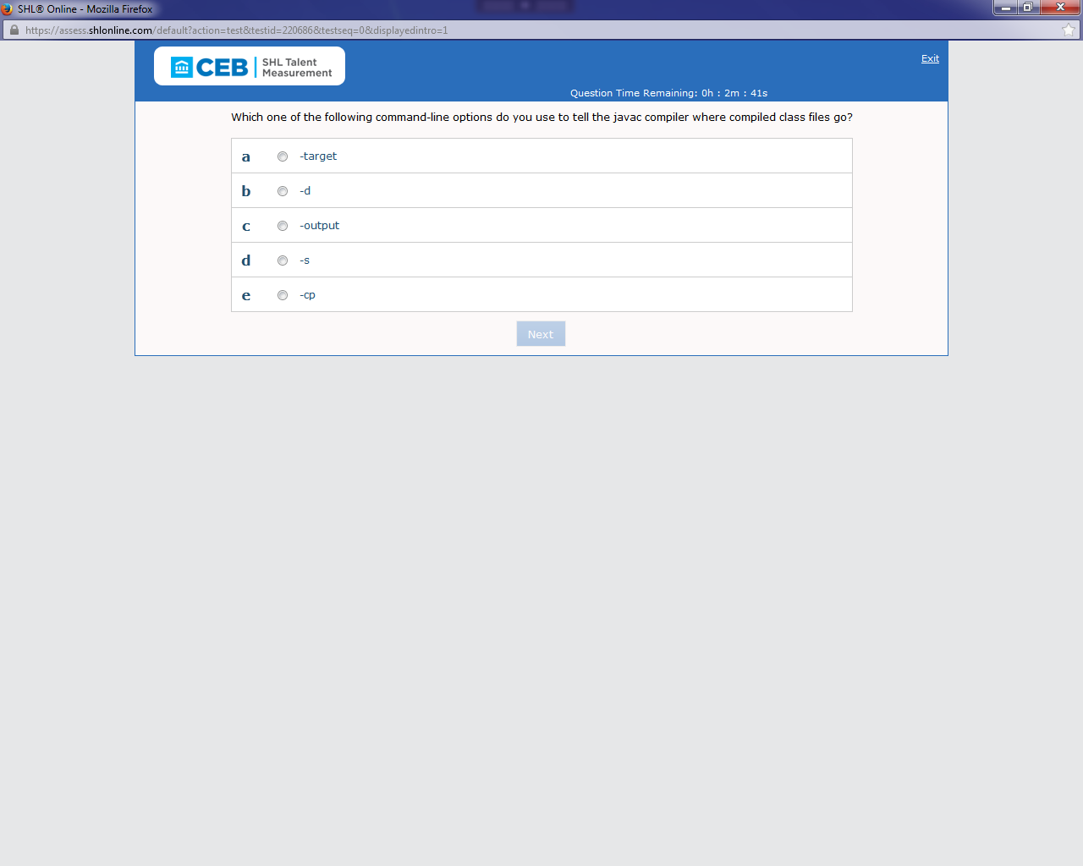

Ans: b{done}

1. layout managers do you use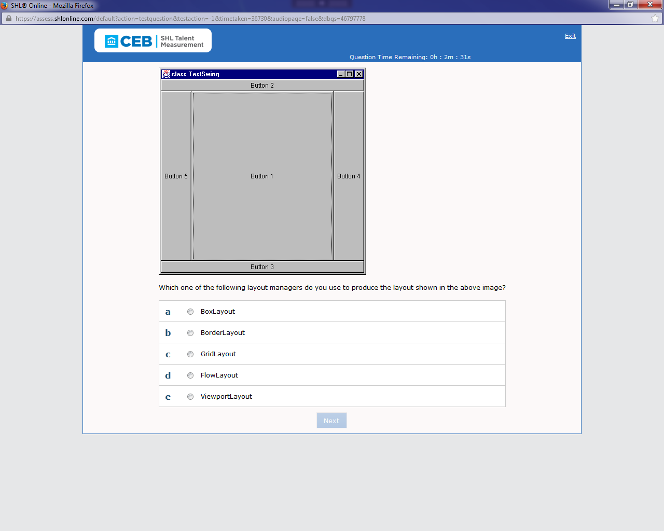

Ans: b{done}

3)For the method in the sample code above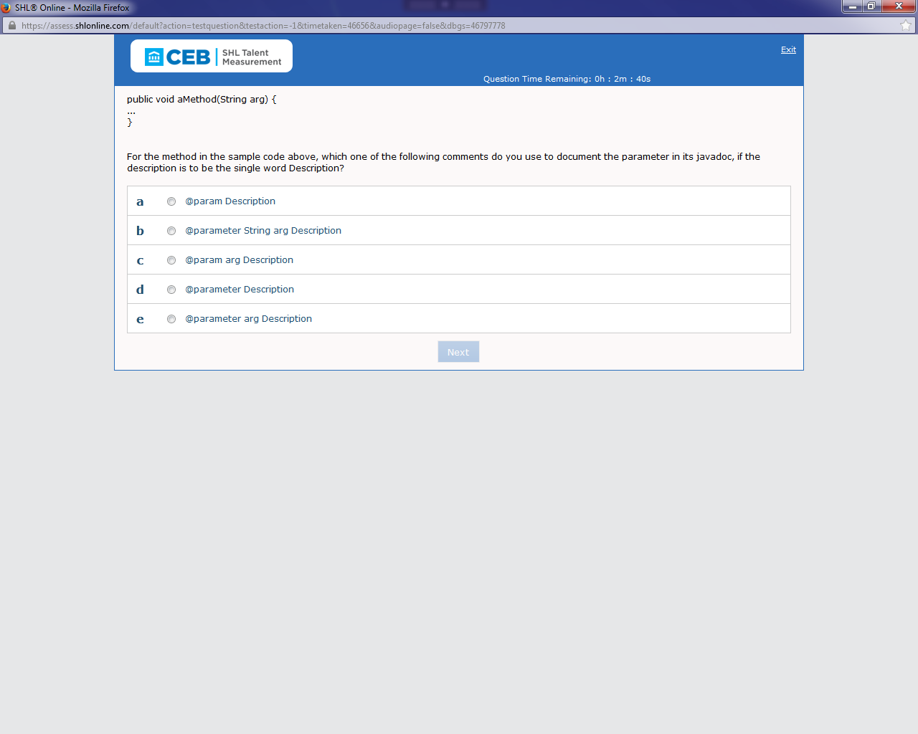

Ans: c{done}

@param parameter_name description

4)Given the class Outer defined in the sample code

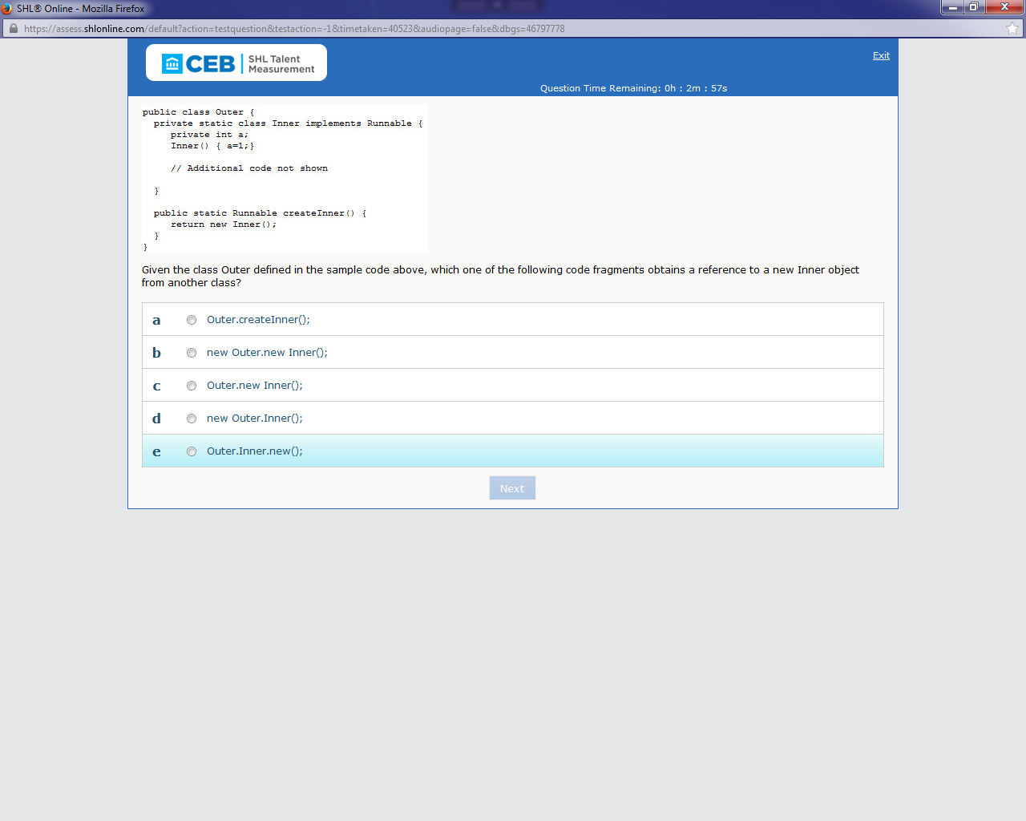

Ans: a{ NOT CONFIRM}

5)Which one of the following is a valid declaration in an interface?

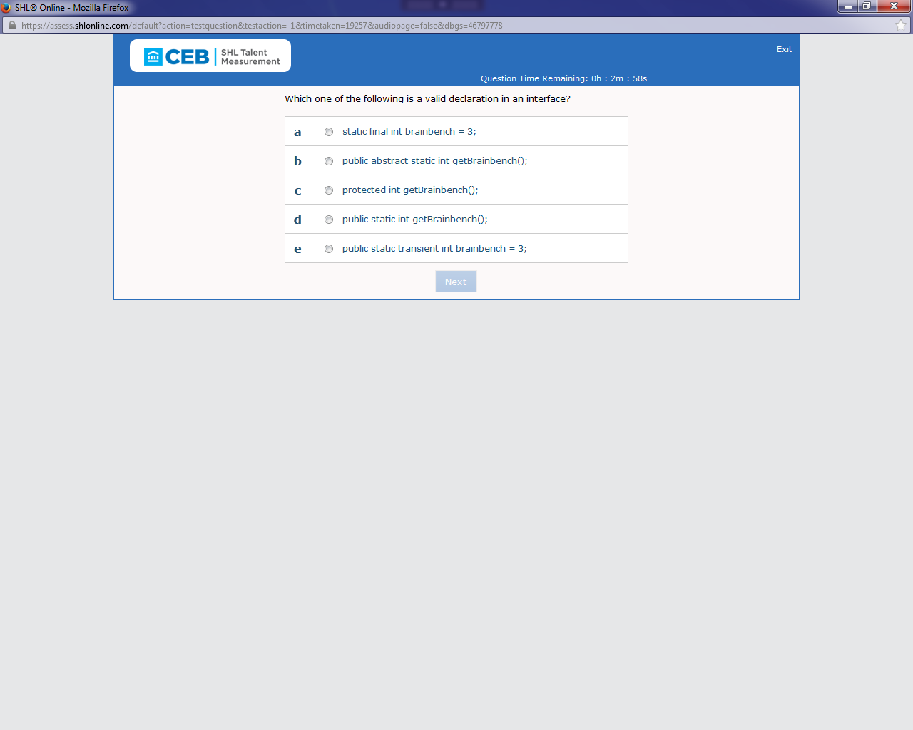

Ans: a{done}

6)Referring to the sample code above, for which one of the following do you use polymorphism during code refactoring?

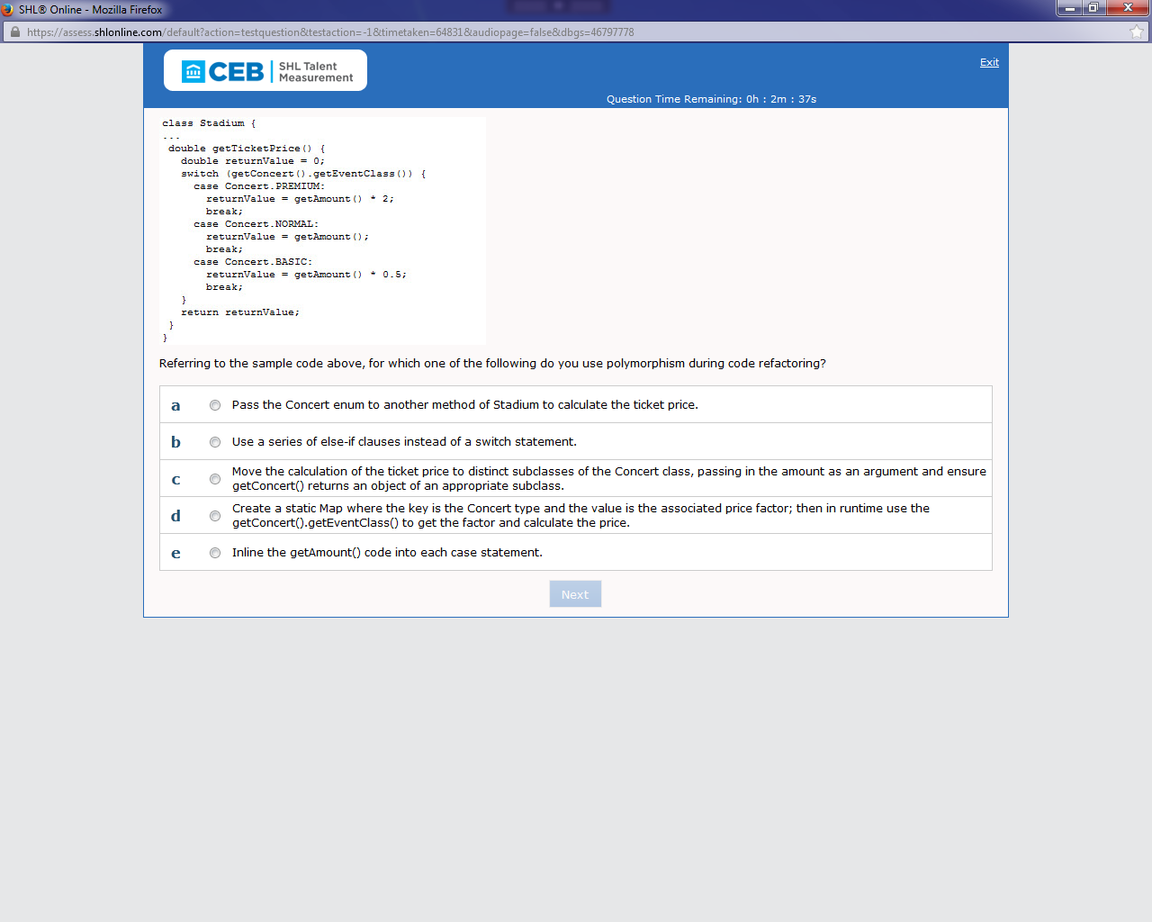

Ans: c{ done}

7)Which one of the following classes do you subclass in order to package several locale-specific versions of a set greetings?

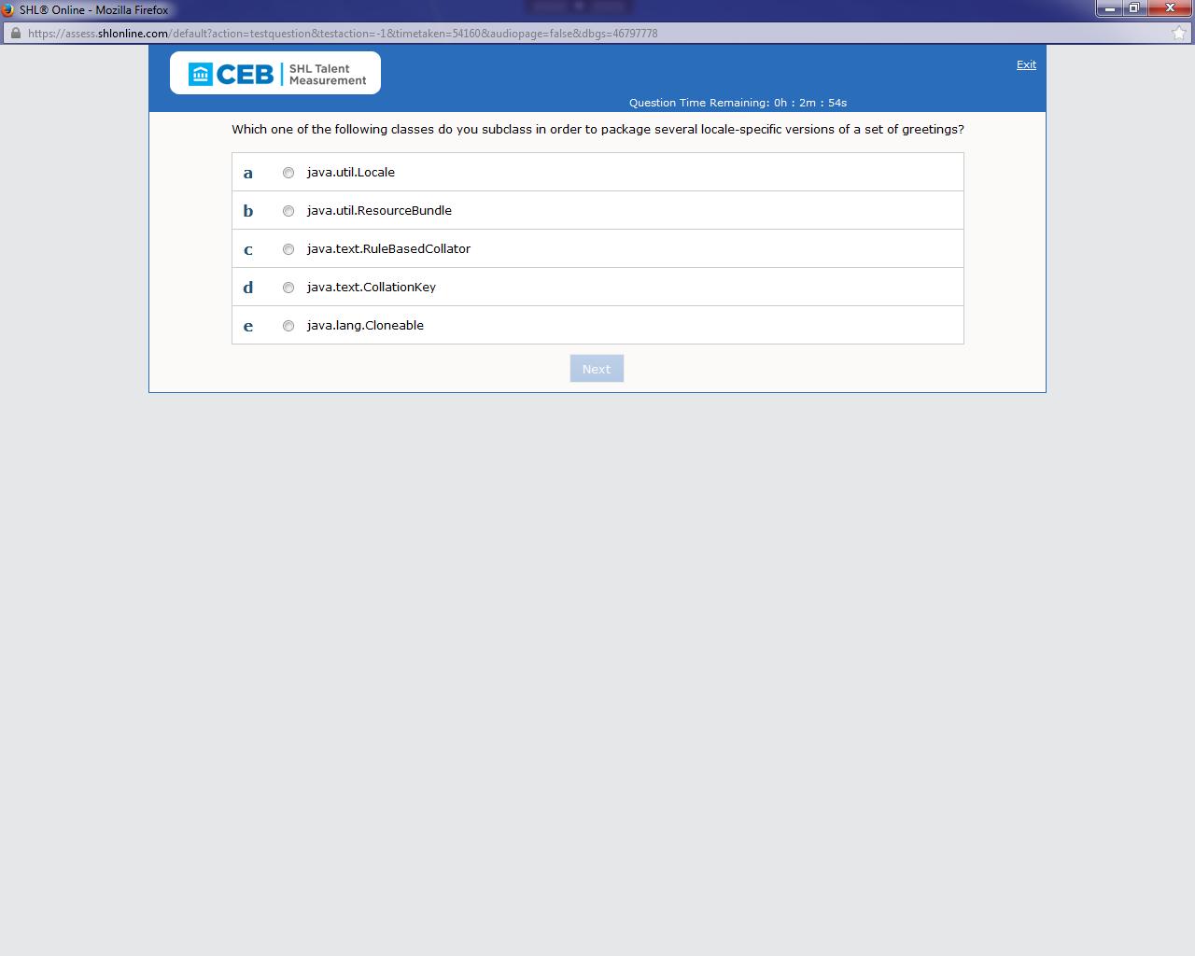

Ans: a

B{CHECK IT ONCE}

8)which one of the following do you use to create a scrollable resultSet?

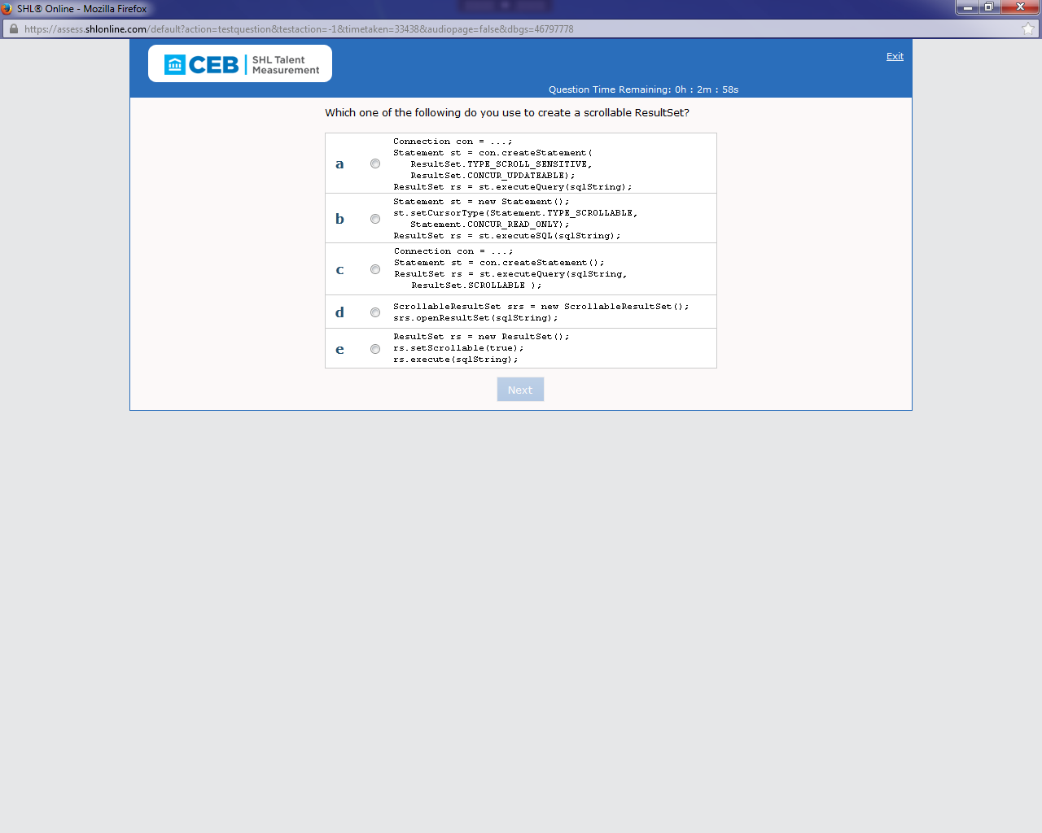

Ans: a{done}

9)Which one of the following methods do you use to make the class defined in the above sample code thread-safe?

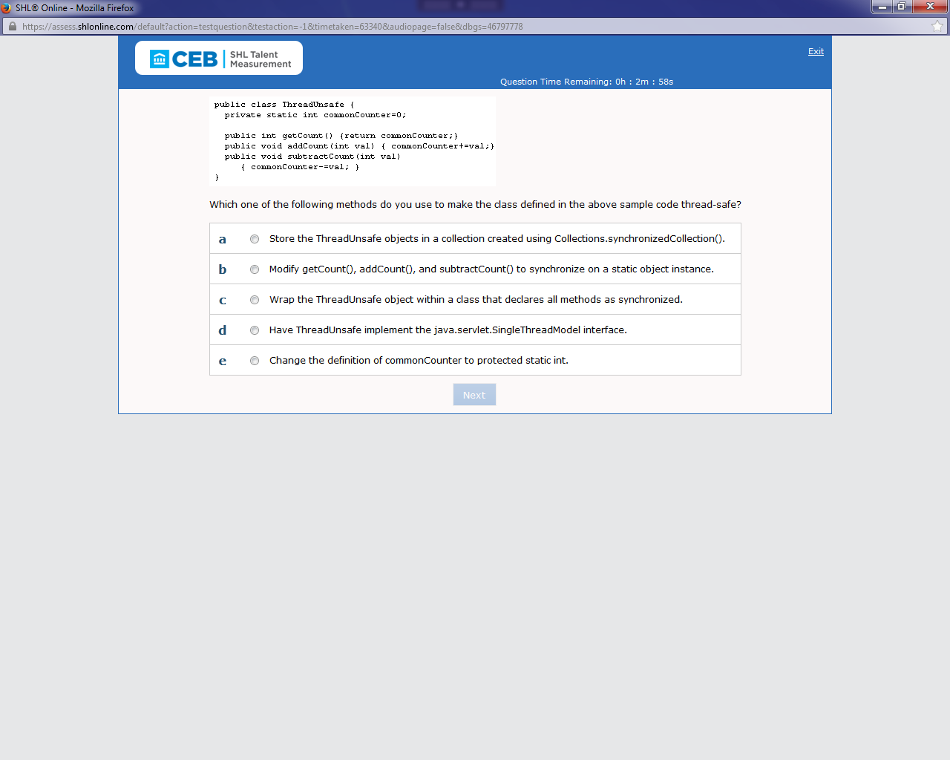

Ans: c{done}

10)In the sample code above,when the varaible list of type java.util.List, how must you declare it so WARNINGS?

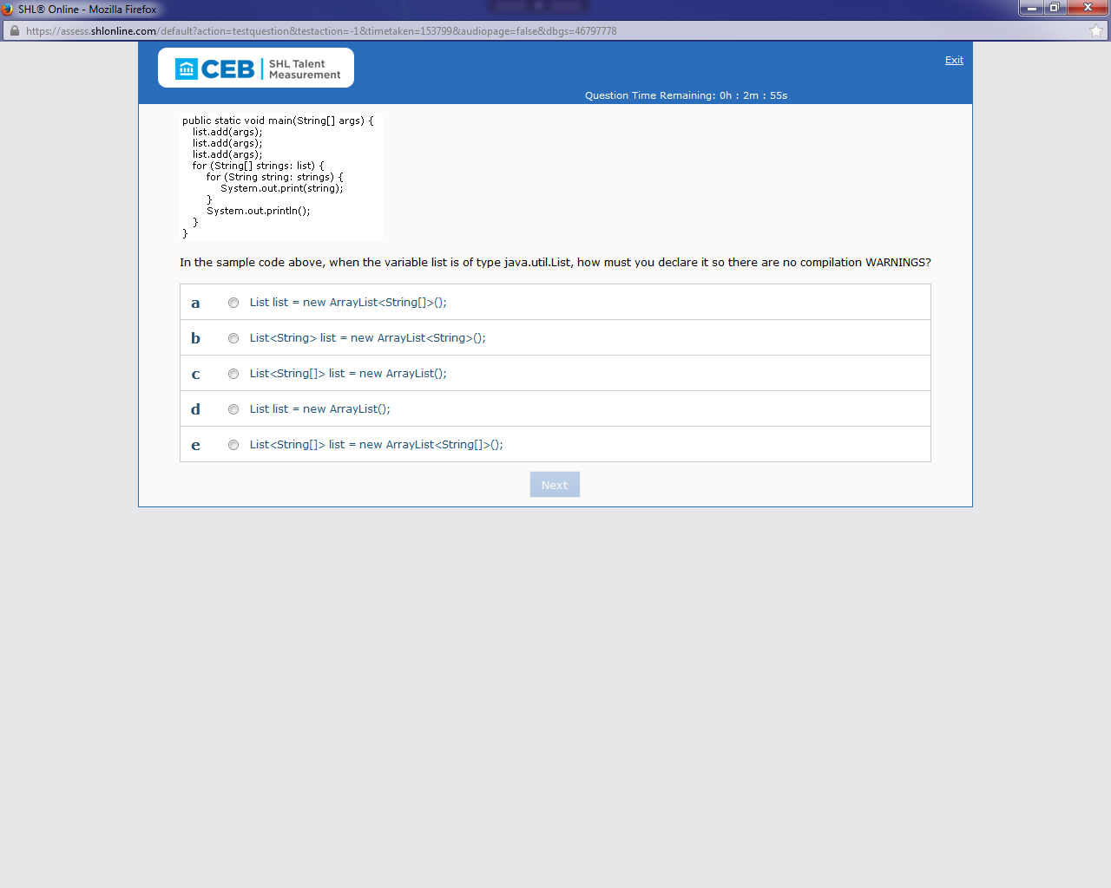

Ans: e{done}

11)Referring to the sample code above, what value is returned when method func(4) is invoked?

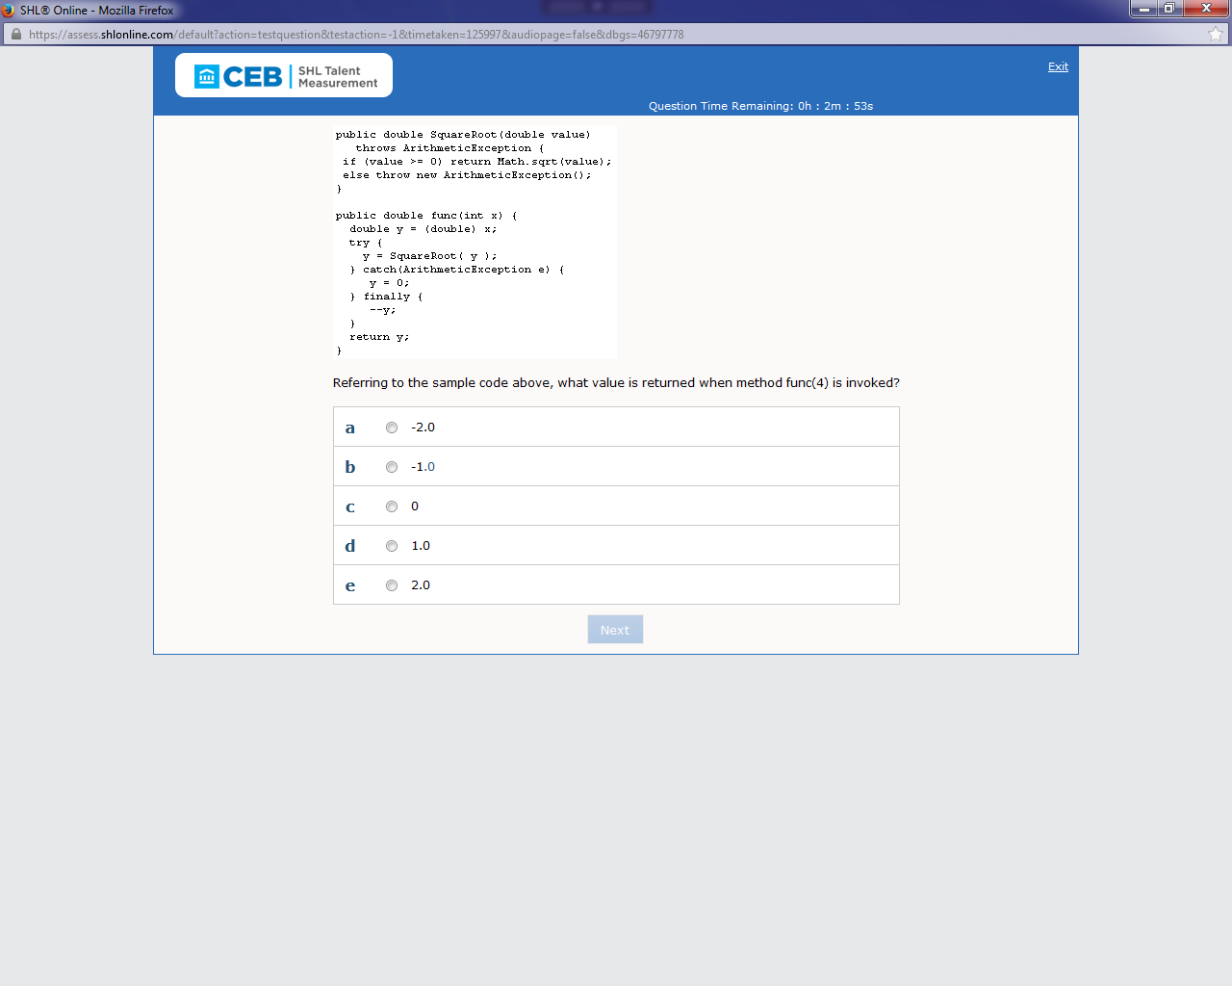

Ans: d{Done CONFIRM IT ONCE}

12)When you invoke the sample code above from the command line,what is the output?

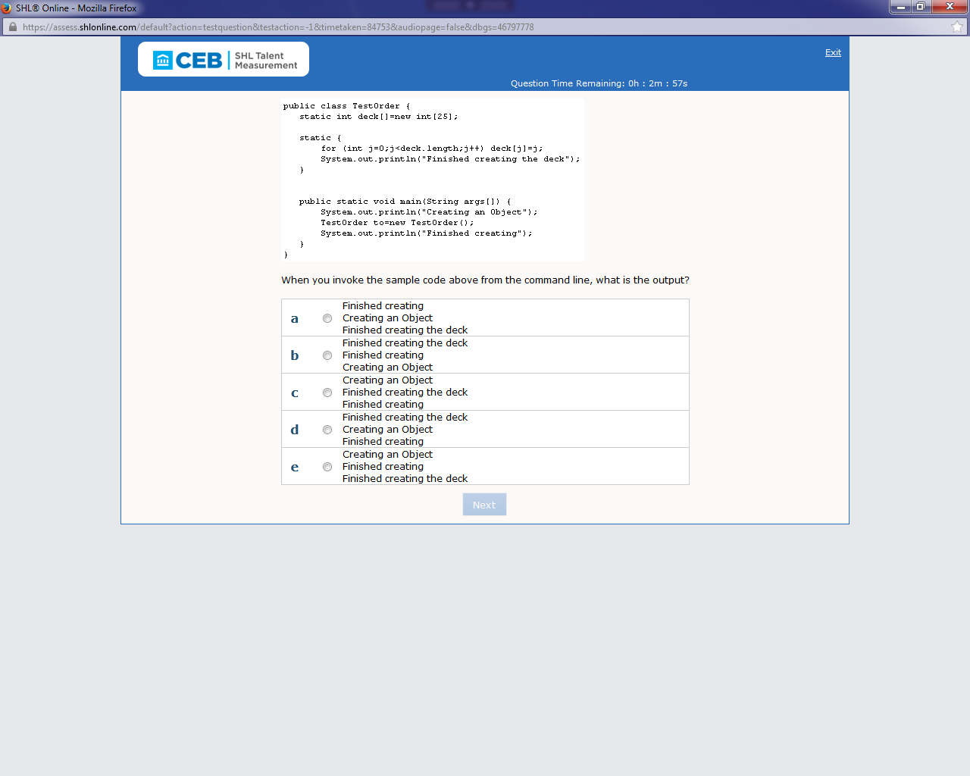

Ans: d{done}

13)In reference to the scenario above, which one of the following statements is always true?

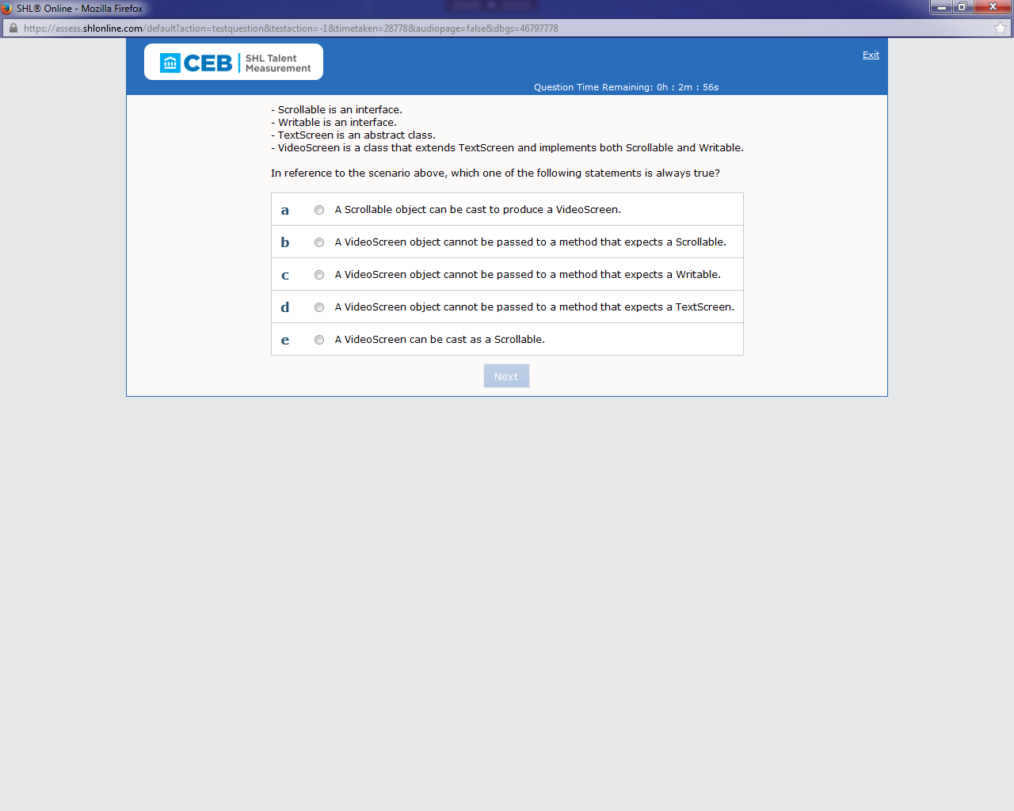

Ans: e{done}

14)Referring to the sample code above, what happens when you add a Jlable to a list of Jbutton objects?

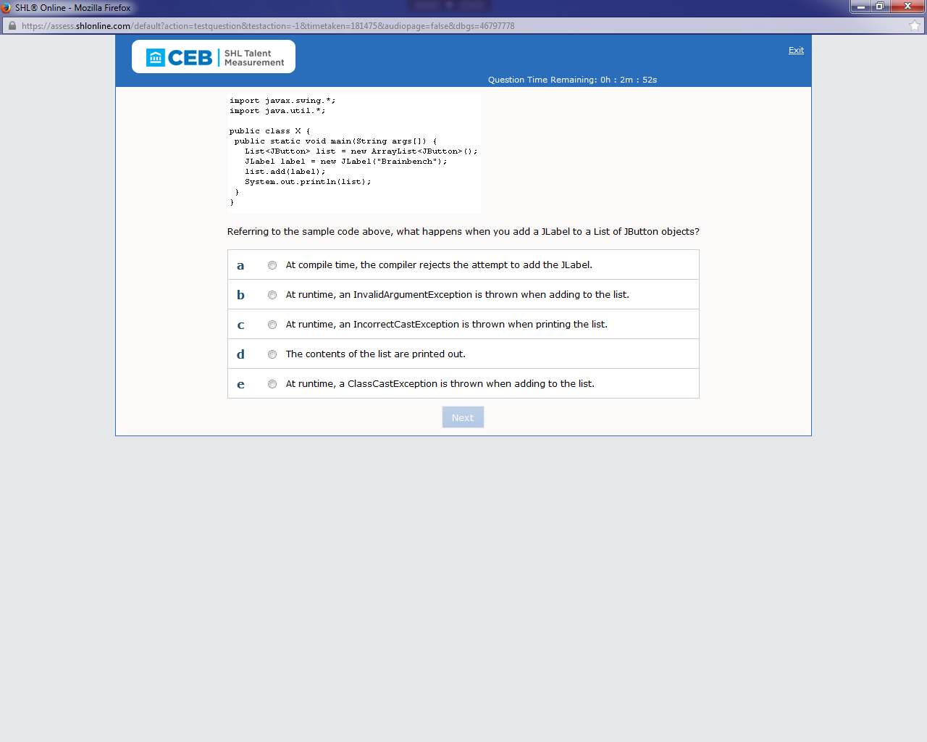

Ans: a{done}

15) Which one of the following code segments listens for a socket connection?

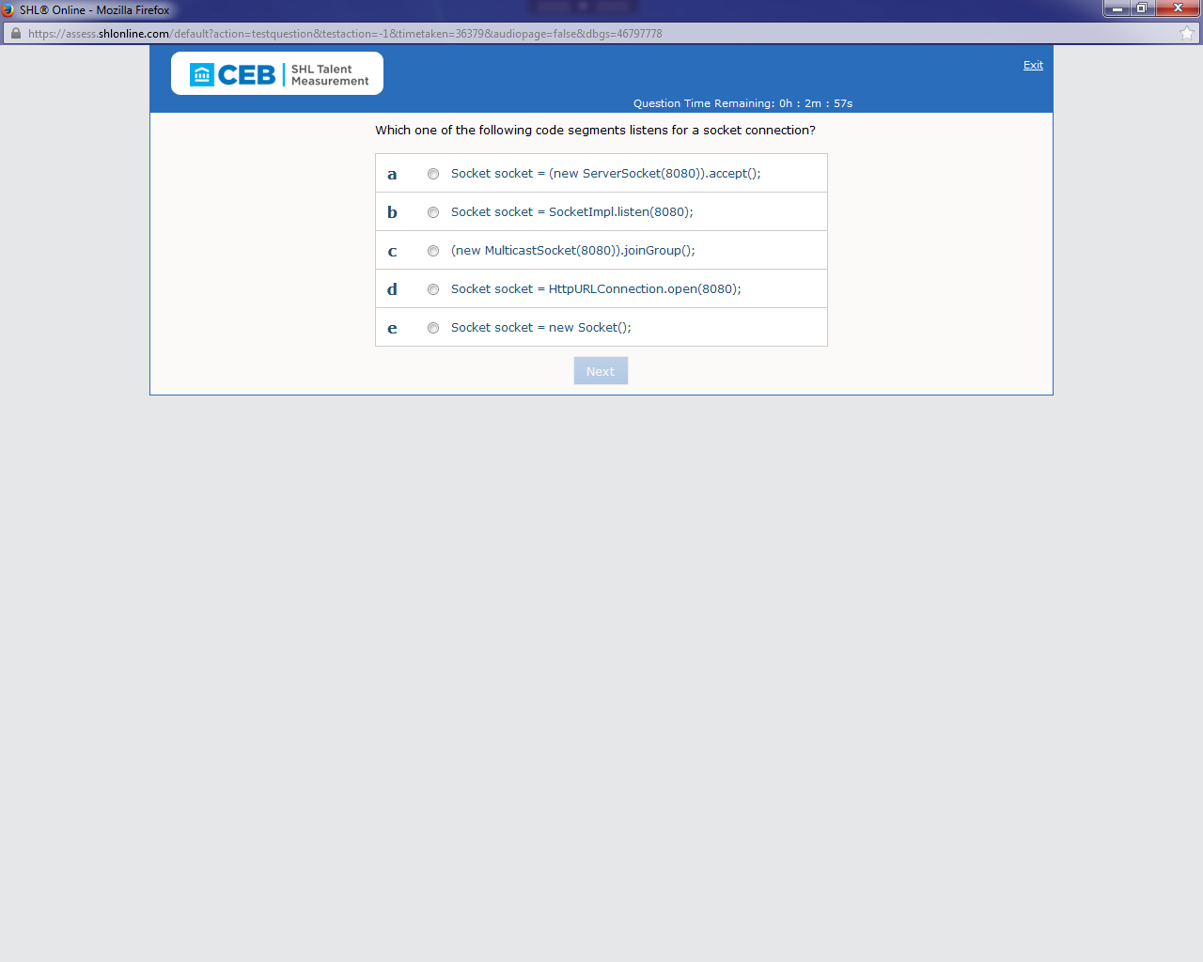

Ans: a{done}

16)Which one of the following replacements for Line A do you use to insert the row defined

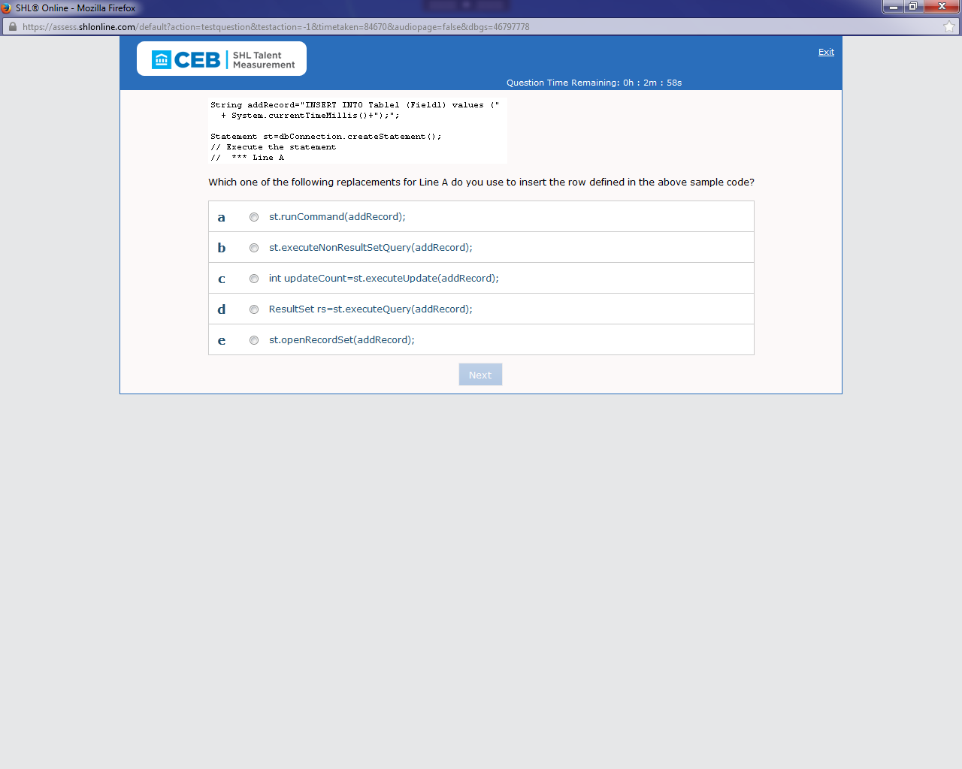

Ans: c{ done}

17) What does double-buffering in animations do?

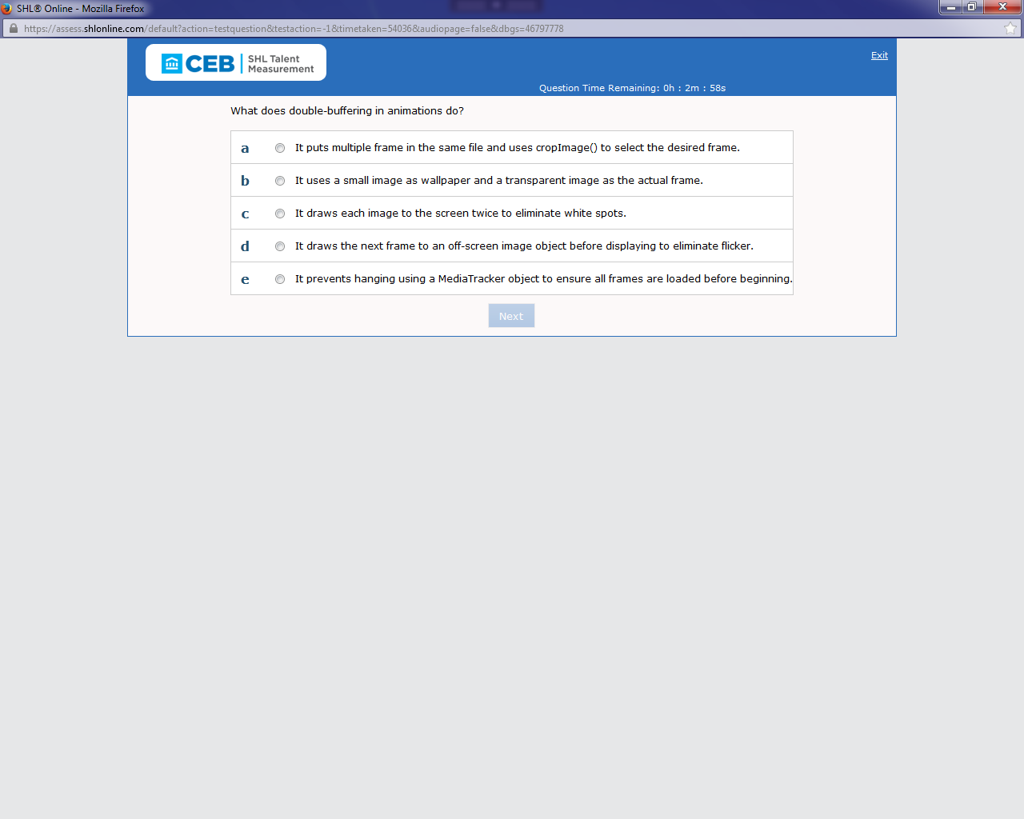

Ans: d{done}

18)Which one of the following do you use to make myList Thread safe in the sample code above?

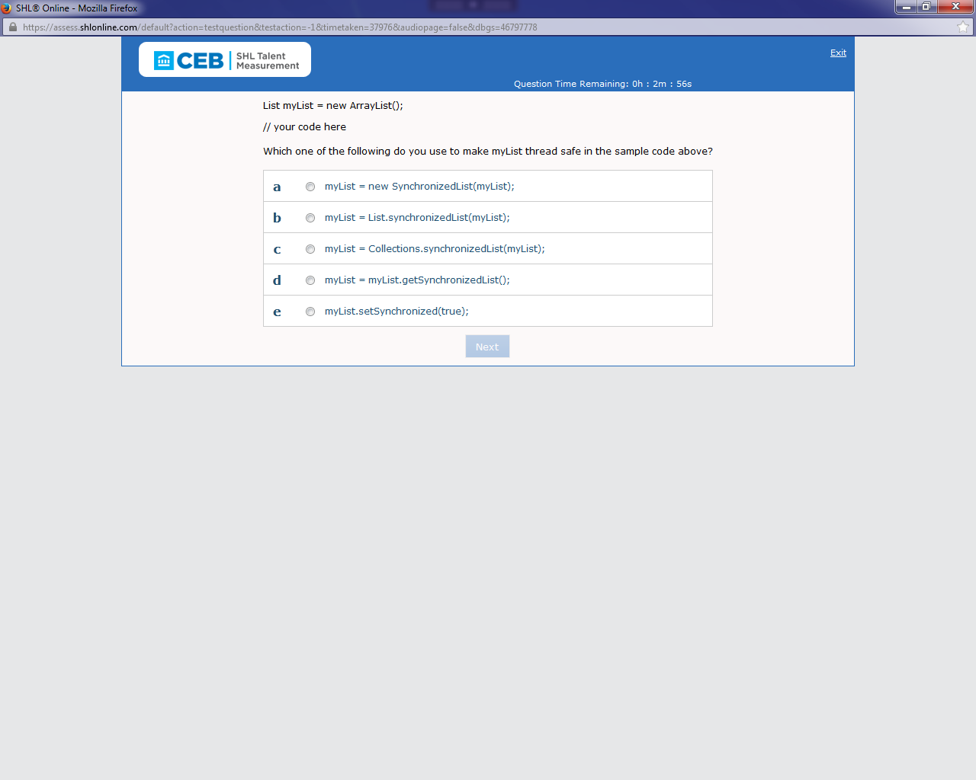

Ans: c{done}

19)What is the value of c after executing the

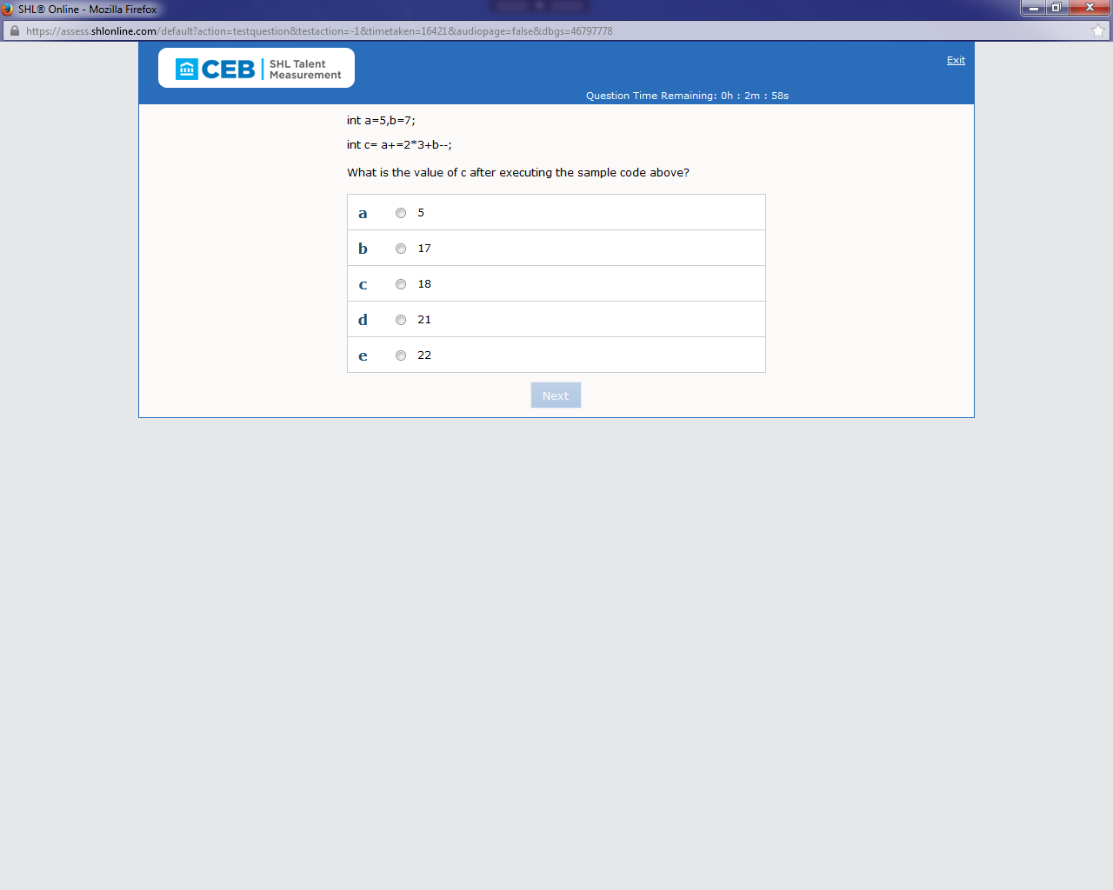

Ans: c{done}

20)What is the potential usage error in the sample code above?

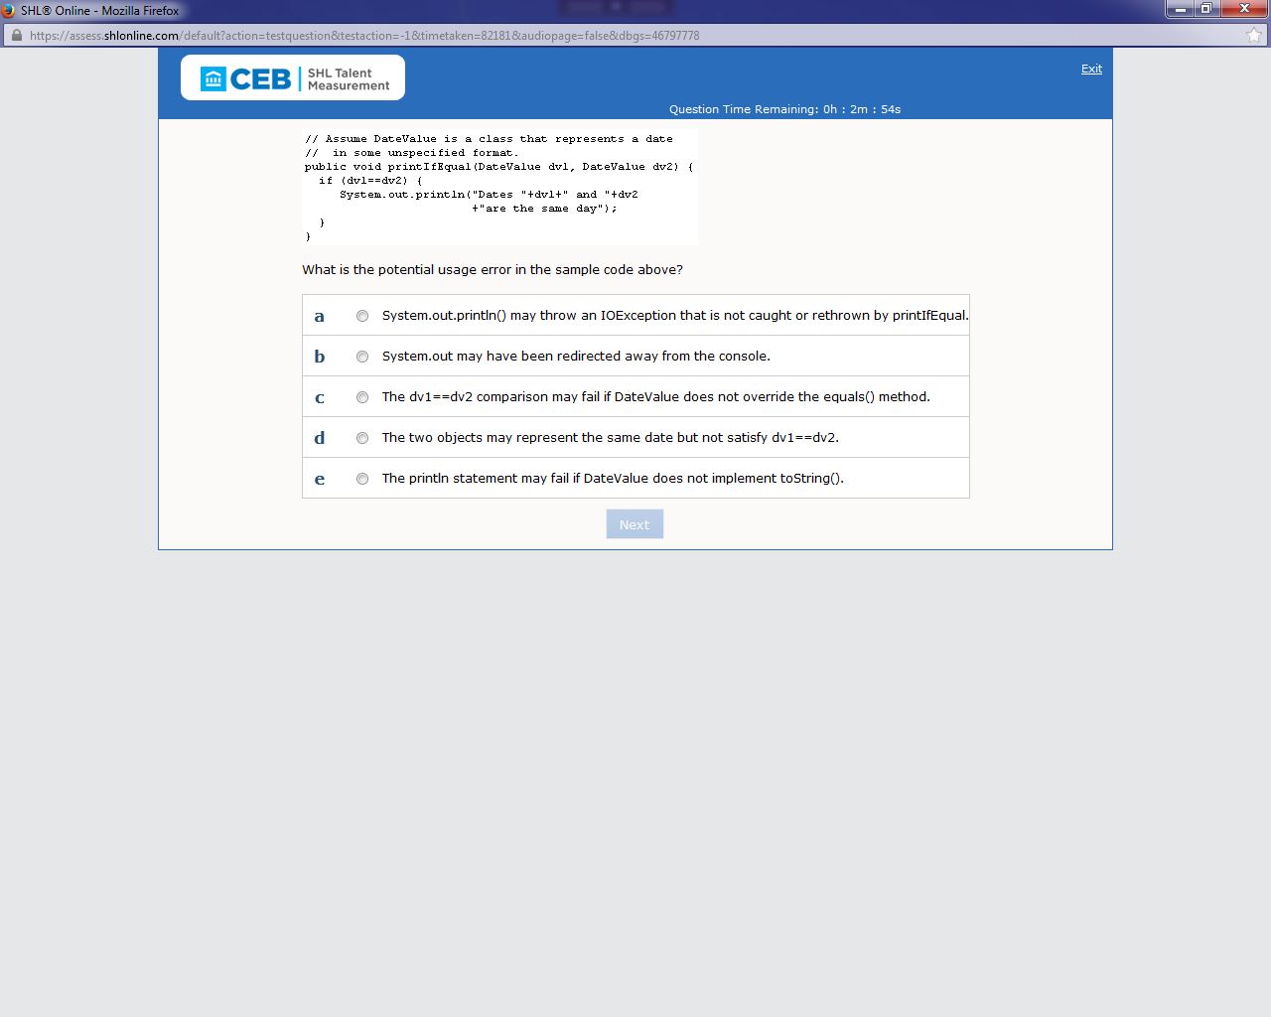

Ans: d(not done)

21)What do you call the concept of renaming classes and varaibles to protect your java code from being reverse engineered and easily read by someone else?

d.Obfuscating{done}

22)public boolean testVal(int a) {

// Line A

}

Which one of the following substitutions for Line A in the sample code above do you use to make the function return true if the value of a is greater than 5 and false

otherwise?

a return (a>5);

b if(a>5) true else false

e if (a<=5) {return=false;} else {return=false;}

d do { return false } if (a<=5);

e return (a<5)?true:false;

ans:b{done}

23)int count=0, i=0;

do{

count += i;

i++;

if (count > 5) break;

} while (i<=4);

What is the value of variable count after the sample code above is executed?

a 0

b 1

C 4

d 6

e 10

ans:d{done}

24)public class SaveObject{

public static void main( String() args )

{

Employee smith = new Employee ("012345","Smith","James","Payroll");

FileOutputStream fos = new FileOutputStream("smith.dat");

ObjectOutputStream oos = new ObjectOutputStream(fos);

oos.writeObject(smith);

fos.close(); }

}

Which one of the following situations prevents the above sample code from working properly?

a The class Employee is declared as transient.

b The file smith.dat is a text file.

c The class Employee does not implement Serializable.

d The class Employee does not have a default constructor.

e e The file smith.dat does not exist.

ans:c{not done}

25)Which collection implements RandomAccess, allowing for fast random access to fetch elements positionally?

a TreeSet

b LinkedHashSet

c LinkedBlockingDeque

d Arraytist

e LinkedList

ans:d{done}

26)class A {

int i=0;

public A() {

i=0;

}

public static void main(String args[]) {

int i = 0;

A h = new A();

while (h.i <= 10) h.doIt();

}

public static void dolt() {

i++;

System.out.println("Hello");

}

}

What happens when the sample code above is executed?

a It prints "Hello" two limes.

b It prints "Hello" three limes.

C It prints "Hello" 11 times.

d It does not compile because variable i has been declared twice.

e It does not compile because don() cannot reference non-static variable i.

ans:e{done}

27)FileInputStream f = new FileInputStream("store");

ObjectInputStream in = new ObjectInputStream(f );

Object obj = in.readObject();

Additional code here

Based on the sample code above, which one of the following code snippets would you use as a part of "Additional Code Here" to discover the type of object represented by obj?

a ClassLoader.getInstance(obj);

b obj.toStringQ;

c obj.getClassQ;

ans:c{not done}

28)void shifter(int[] array, int arrayLength) {

System.out.println("Go");

synchronized (array) (for int i=1;i<arrayLength;i++) {

array[i-1] = array[i];

}

}

}

What does the synchronized (array) code block do in the sample code above?

a It forces the thread to obtain the monitor for array before continuing.

b It performs the same as dedaring shifter() as synchronized.

c It forces the virtual machine to treat array as a static object.

d It sets all methods of the object to synchronized while the code block executes.

e It ensures that any threads created in the code block begin execution in the array object.

ans:a{not done}

29)public class Test {

public static void main(String args[]) {

int i = args.length; switch (i) {

case 0: System.out.println("Zero");

case 1: System.out.println("One");

case 2: System.out.println("Two");

case 3: System.out.println("Three");

default: System.out.println("Default");

}

}

}

Where must you add ©SuppressWarnings("fallthrough") annotation to the sample code above in order for the "javac -Xlint:fallthrough Test.java" command to NOT generate any warnings?

a Immediately above the switch statement

b Within the javadoc for the class

c Before each case clause that falls through

d Within the class import declaration

e Above the main method declaration

ans:e{done}

30)what must you do to perform deanup when a user is trying to close a window?

a Implement FrameListener and place deanup code in a frameClosing(FrameEvent e) method.

b Implement WindowListener and put deanup code in a public void windowClosing(WindowEvent e) method.

c Place deanup code in a try-catch block that catches a FrameClosingException.

d Wait for the garbage collector to do automatic cleanup.

e Create an inner class called WindowListener, extend WindowEventHandler, and put deanup code in a processEvent(Event e) method.

ans:b{done}

31)Which one of the following classes do you use to store a set of <key,value> pairs that are sorted by the key and NOT inserted randomly'

a LinkedHashMap

b HashMap

C LinkedList

d TreeMap

C TreeSet

ans:d{done}

32)public class Sample {

String name;

private Sample(String name)

{

this.name = name;

}

@Override

public int hashCode() {

return name.hashCode();

}

@deprecated

public static String getCompanyName(){

return "Brainbench";

}

public String getName(){

return name;

}

}

Which one of the following is the reason the sample code above causes a compilation error?

a The class does not have any public constructors.

b The annotation for overriding methods is ©override, not ©Override.

C The hash code method is spelled hashcode, not hashCode.

d The annotation for deprecated methods is ©Deprecated, not @deprecated.

e The class does not have a public no-argument constructor.

ans:d{done}

33)Which one of the following lines of code do you use to return the HTML text of the root Web page at www.brainbench.com?

a HTMLDocument doc = a HTMLDocument.create("http://www.brainbench.com");

b String content = new FileInputStreamchttp://www.brainbench.comThread();

c Object content = C "-/ new URL("http://www.brainbench.com").readObject();

d Object content = new URL("http://www.brainbench.com").getContent();

e Integer content = URL.get("http://www.brainbench.com").getContent();

ans:d{not done}

34)How do you count the number of lines in a text file?

a Ask a LineNumberInputStream after reading the whole file.

b Ask a LineNumberReader after reading the whole file.

C Subclass FilterinputStream and count the number of \ru characters that go by.

d Read the file a line at a time via a BufferedOutputStream.

e Ask a LineNumberReader before reading the whole file.

ans:b{done}

35)Which one of the following mechanisms do you use to directly change an XML file from one DTD into another?

a Schema

b XSLT

C StAX

d XPath

e SAX

ans:b{done}

36)public class Test {

public static void main(String() args){

StringBuffer() messages = new StringBuffer[S];

messages[0].append("Hello, World!");

System.out.println("First message is " + messages[0]);

}

}

Which one of the following is the result when you run the above sample code?

a An ArraylndexOutOfBounds is thrown.

b A NullPointerException is thrown.

C First message is Hello, World!

d The code does not compile.

e First message is null.

ans:b{done}

37)ByteArrayOutputStream baos = new ByteArrayOutputStream();

ObjectOutputStream out = new ObjectOutputStream(baos);

out.writeObject(new StringBuffer("HelloWDS011uDFFE"));

byte bArray()= baos.toByteArray();

In the sample code above, after execution, what does the array named bArray contain?

a A hash code created from StringBuffer

b The status of ByteArrayOutputStream baos (0x20 open, Ox21 closed)

c A reference to ByteOutputStream baos

d Unicode values for each character in Hello

e A serialized version of a StringBuffer object containing string "Hello\uD801\ulDFFE"

ans:e{done}

38)Which one of the following is NOT a valid reference in an @see javadoc tag, when you want to reference another field, method, constructor, or class?

a see Class#Constructor(Type, Type...)

b see package.Classiffield

C ©see *field

d @see package#field

e ©see #method(Type id, Type id...)

ans:d{not done}

39)Which one of the following Java APIs do you use to look up a Java MBean?

a JDBC

b Jini

C JMS

d IMP'

e MD'

ans:b{not done}

40)EnhancedForStatement: for (Type Identifier : Expression) Statement

As defined in the sample code construct above, what interface must the Expression implement in order for you to use it with the enhanced for loop construct?

a Hashtable

b Map

C Enumeration

d Iterable

e Iterator

ans:d{done}